**CMPE287 – Software Quality Assurance and Testing**

**Deliverable #2B – AI Test Report**

**Group-3 Team Members**

Tirumala Saiteja Goruganthu – 016707210

Harish Marepalli – 016707314

Sowjanya Bheemineni – 016672214

Sohan Leburu – 017408768

**Guided By**



Prof. Jerry Gao

**Table of Contents**

AI Testing Tool – Credentials 3

1. AI Function Test Requirement Analysis 4

1.1 Overview 4

1.2 AI Function Test Requirements 5

1.3 AI Function Test Requirements Modeling 5

2. AI Test Modeling for Selected AI Features 5

2.1 Context Modeling for each selected AI-powered Function/Feature 5

2.2 AI-powered function input classifications 6

2.3 AI-powered function output/event/action classifications 7

2.4 AI-powered function classification decision tables 8

3. AI Function Test Cases with Inputs/Expected Outputs 9

3.1 AI-powered function test sets 9

# AI Testing Tool – Credentials

**Username:** saiteja377

**Password:** Naruto@377

**AI Testing Tool:** http://3.14.249.198:8080/login

# AI Function Test Requirement Analysis

## 1.1 Overview

**Photo Math**

**Photo Math:** Photo Math is an AI based educational mobile application owned and maintained by Google. It operates as a computer algebra system combined with an advanced optical character recognition system tailored for utilization with a smartphone's camera to scan and identify mathematical equations. Following the scanning process, the application proceeds to display methodical explanations directly on the screen.

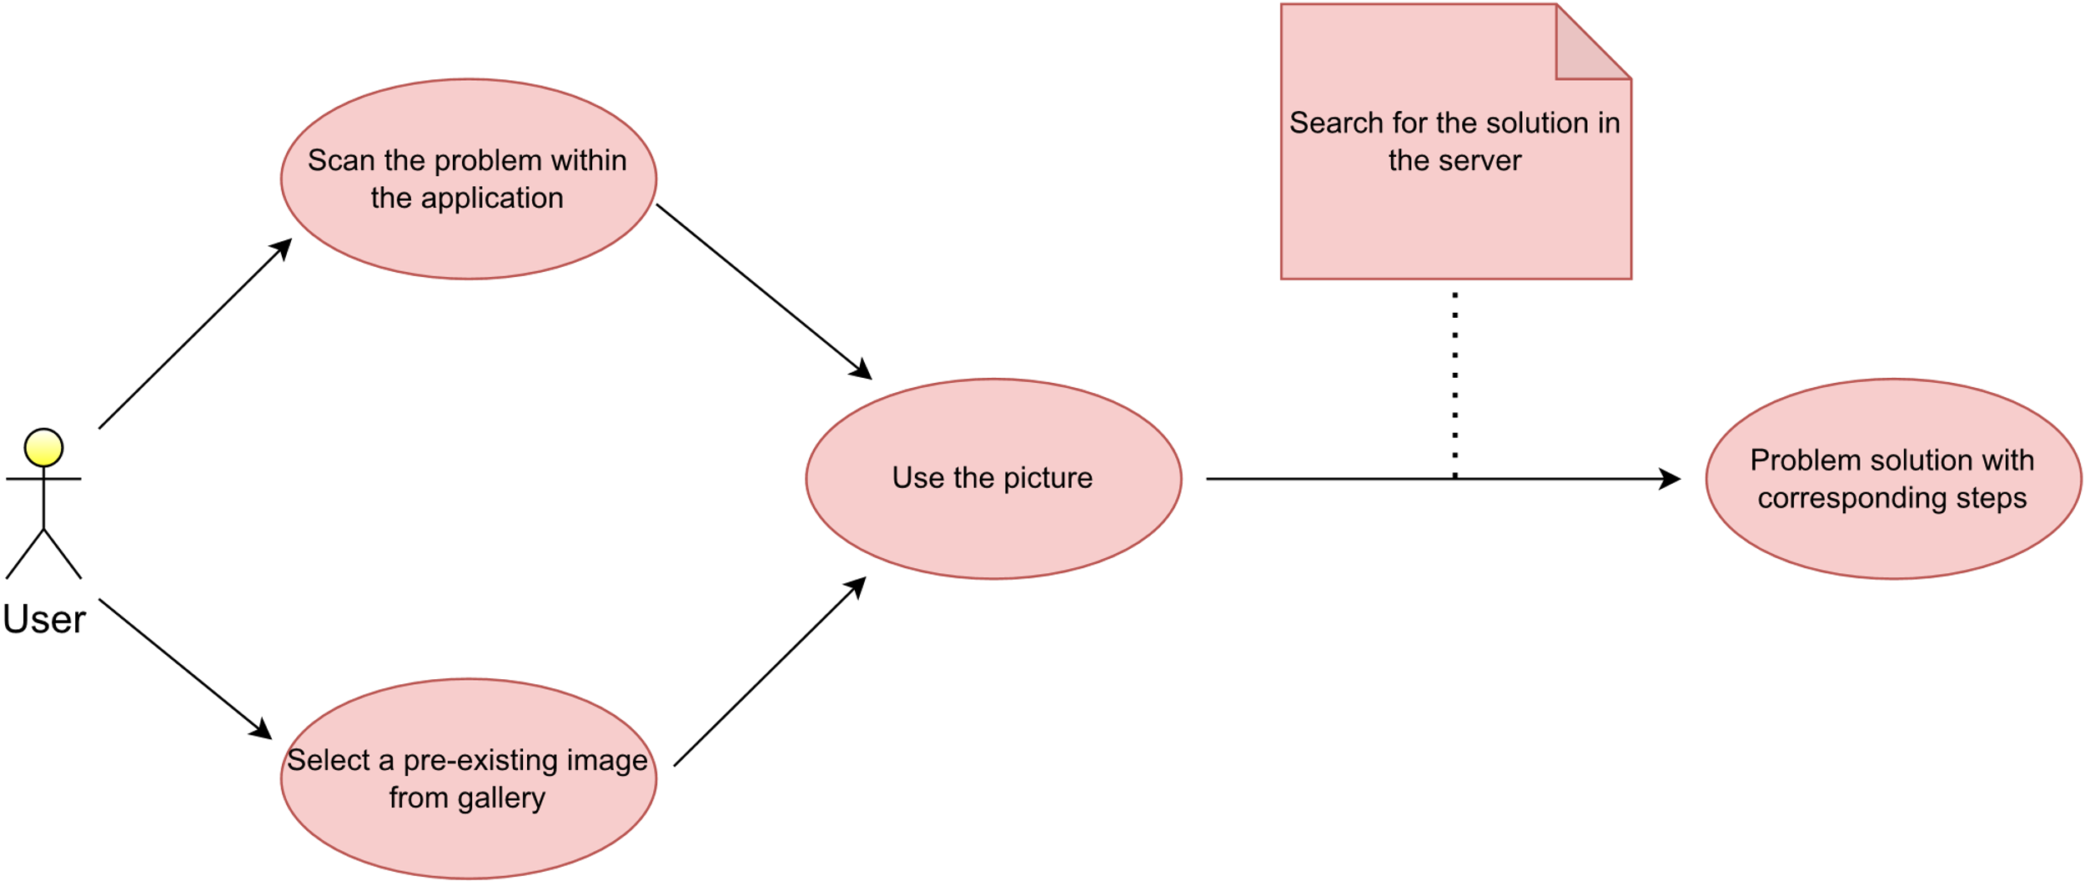

Figure 1.1– AI Function Scenario Diagram

## AI Function Test Requirements

The primary divisions within artificial intelligence consist of machine learning (ML), natural language processing, and image recognition. To establish the criteria for testing the functionality of AI, we will assess whether the selected apps for testing incorporate these specific AI subcategories.

The AI feature we will investigate is Image Recognition. Here are the procedures for assessing this capability:

* Acquire the Image
* Evaluate the Input
* Produce the Outcome

## AI Function Test Requirements Modeling

We are utilizing an AI testing tool to build models for AI function test requirements. This tool will assist us in constructing context trees as well as input and output classification trees. Our objective is to pinpoint the specific features and represent them within these trees. The main nodes within these trees are input, context, and output, which will be subdivided into subcategories based on the identified features. The terminal nodes, represented by leaf nodes, cannot be further divided into features. These leaf nodes represent distinct types of test cases that will undergo testing. The depth of each tree within the input, context, and output classifications is set at 3 levels.

# AI Test Modeling for Selected AI Features

Image Recognition is the AI feature employed in Photomath application. Consequently, all the test cases conducted revolve around image inputs, and the specific AI function under test is Image Recognition. Numerous test cases, each involving distinct scenarios, are executed to evaluate the image recognition functionality of the Photomath application.

## 2.1 Context Modeling for each selected AI-powered Function/Feature

With respect to modeling the context for the selected AI feature (Image), we have categorized it into 4 types. We have content, font, language, and image clarity. Again, each of these categories is subdivided into two different categories. Content can be a Mathematical Equation, Non-Mathematical Equation. The font, on the other hand, can be computer written or human written. Similarly, the language could be English or any language other than English. Finally, the image clarity can be good or bad.

The following image shows the context modeling done using the AI Testing tool:

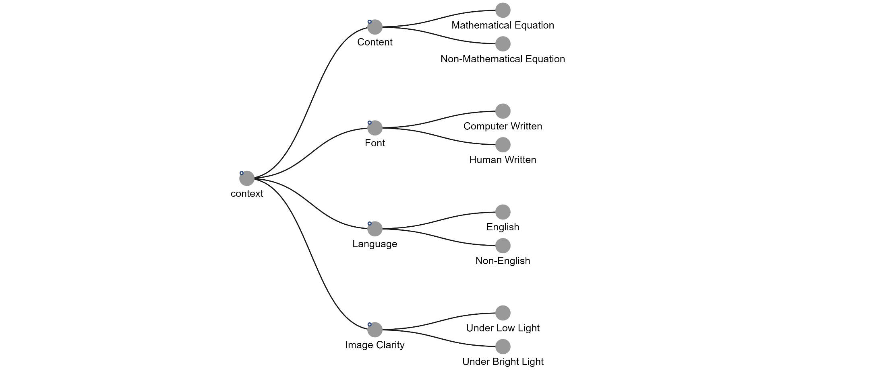

## AI-powered function input classifications

With respect to the input modeling, we have categorized it into two variants. One is related to the type of equation, and other is regarding the number of variables used. The type of equation is again subcategorized into 5 different categories. They are, Linear Equation, Quadratic Equation, Polynomial Equation, Exponential Equation, Logarithmic Equation. Finally, the number of variables could be single variable inputs or multi-variable inputs.

The following image shows the input modeling done using the AI Testing tool

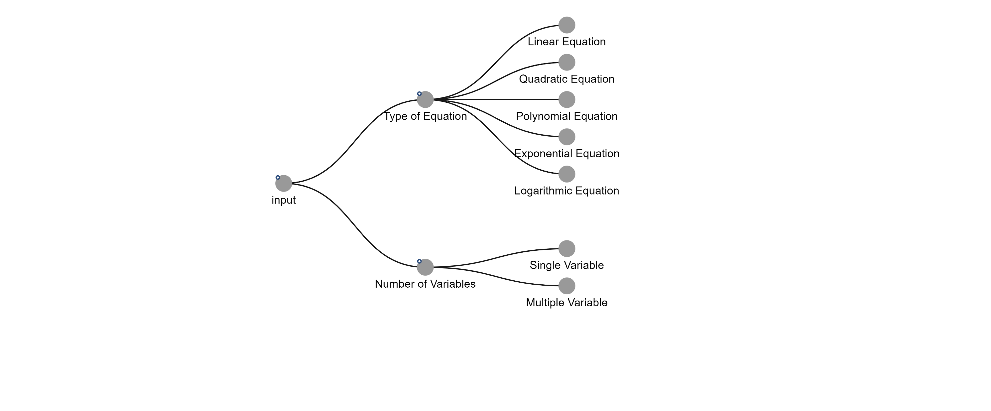

## AI-powered function output/event/action classifications

With respect to the output modeling, we have categorized it into two variants. One is related to the solution, and other is regarding the error message given. The solution is again subcategorized into 2 different categories. We can have Graphical-based solution and value-based solution. Finally, the error message could have ‘cannot recognize the image’ message or ‘cannot find the solution’ message.

The following image shows the output modeling done using the AI Testing tool

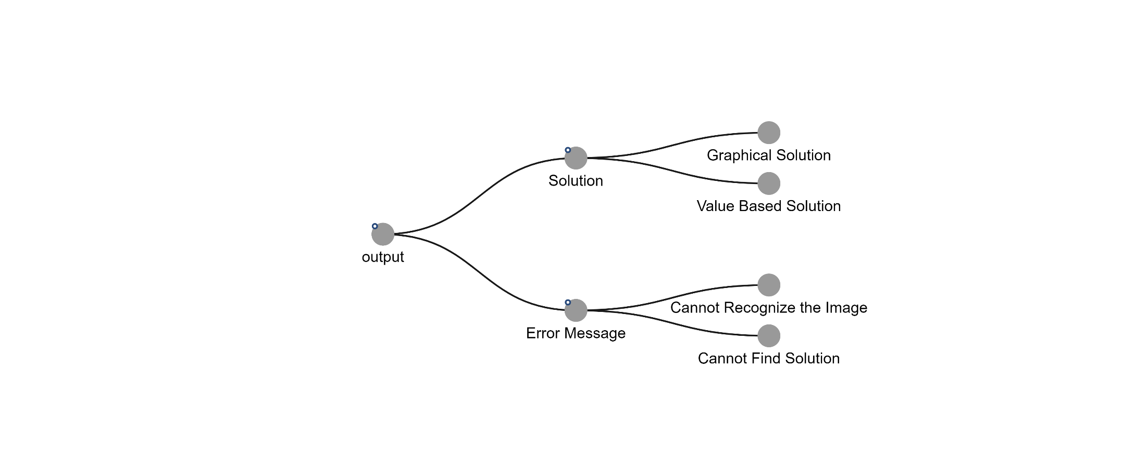

## AI-powered function classification decision tables

A 3D Decision table is generated from the AI testing tool by the utilizing the above context, input, and output modeling trees.

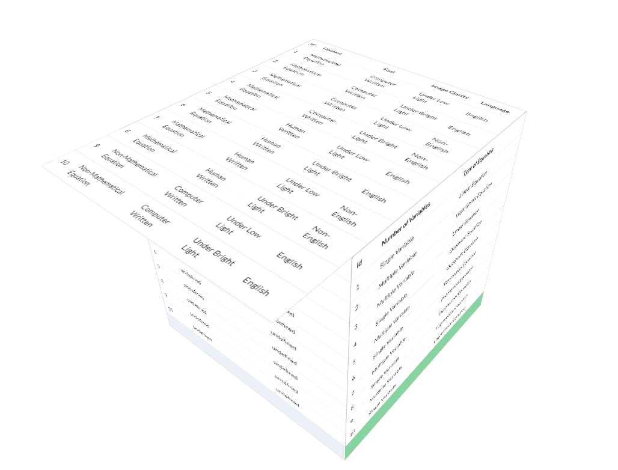

# AI Function Test Cases with Inputs/Expected Outputs

## 3.1 Test data models

As you can see in the above 3D decision table, we have “undefined” in the output section of the decision table. This is because we have not yet defined the expected outputs in the tool.

The following snippet shows how we modified the expected output:

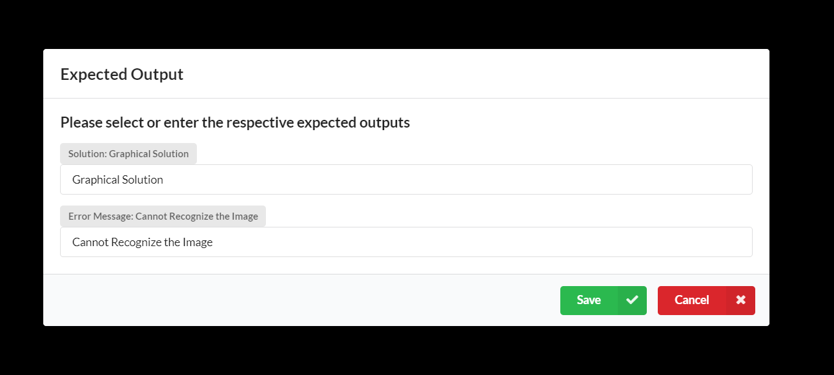

After changing the expected outputs of all the test cases, we have the following modified 3D decision table shown in various angles.

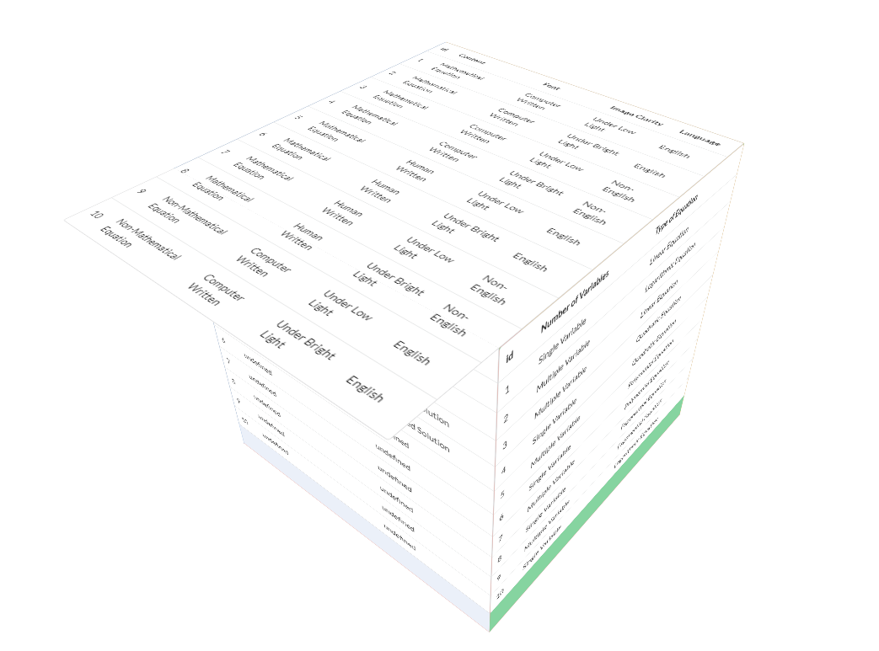

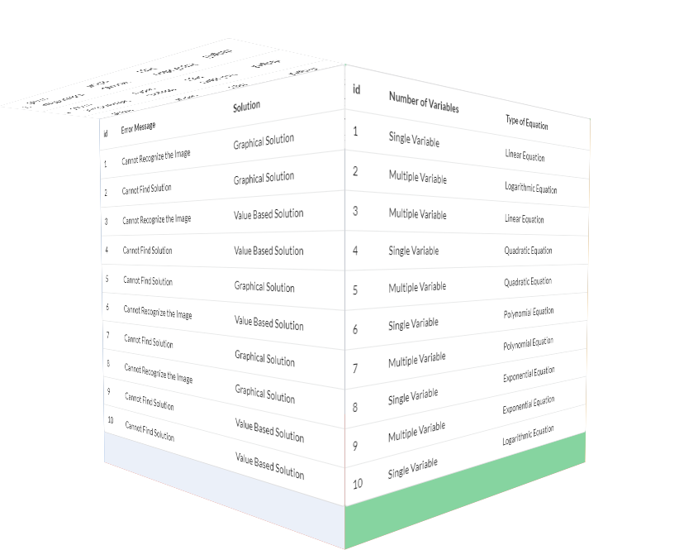

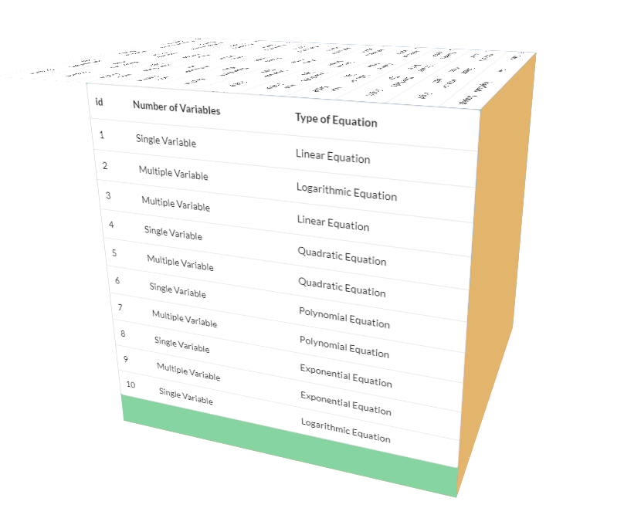

The AI testing tool has generated testcases based on the given 3 tree models. The following series of snippets depict the generated testcases.

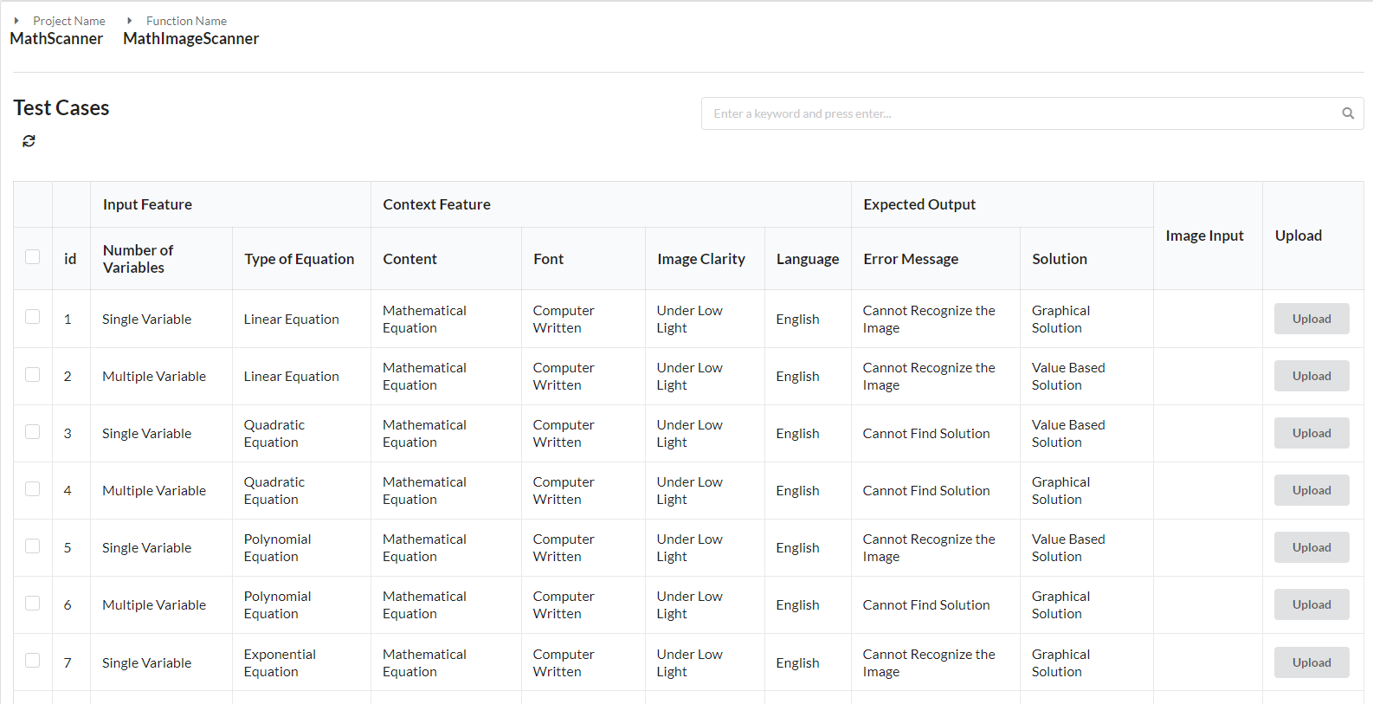

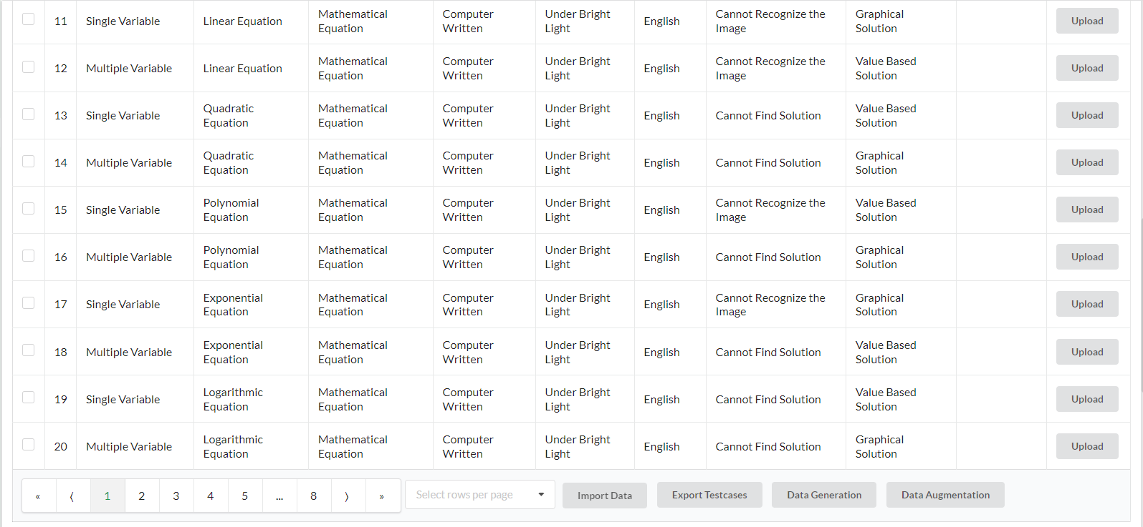

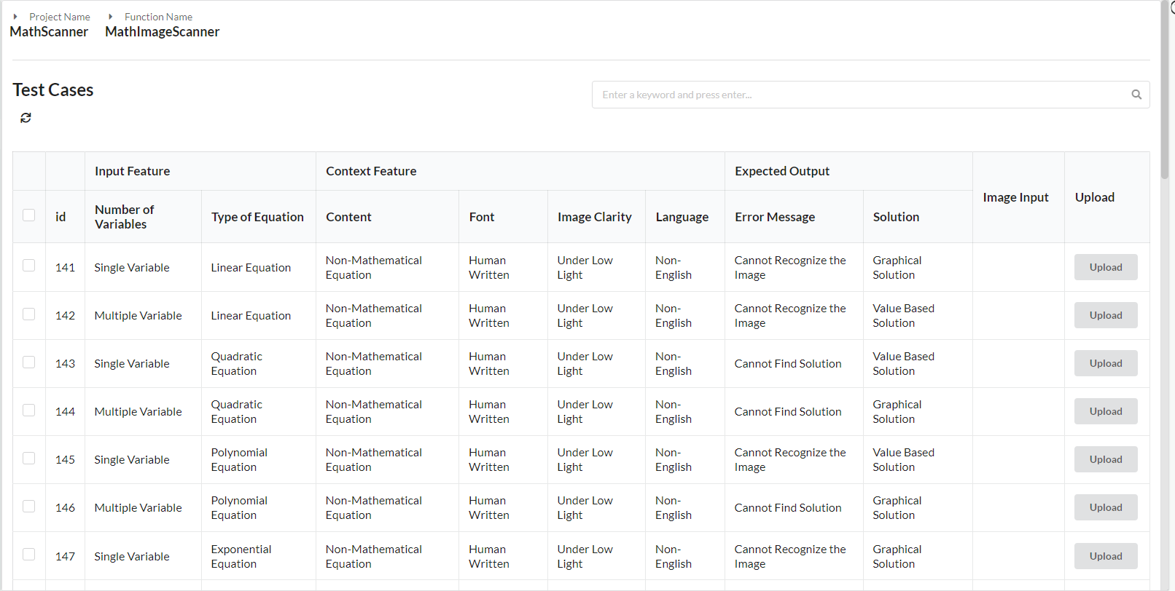

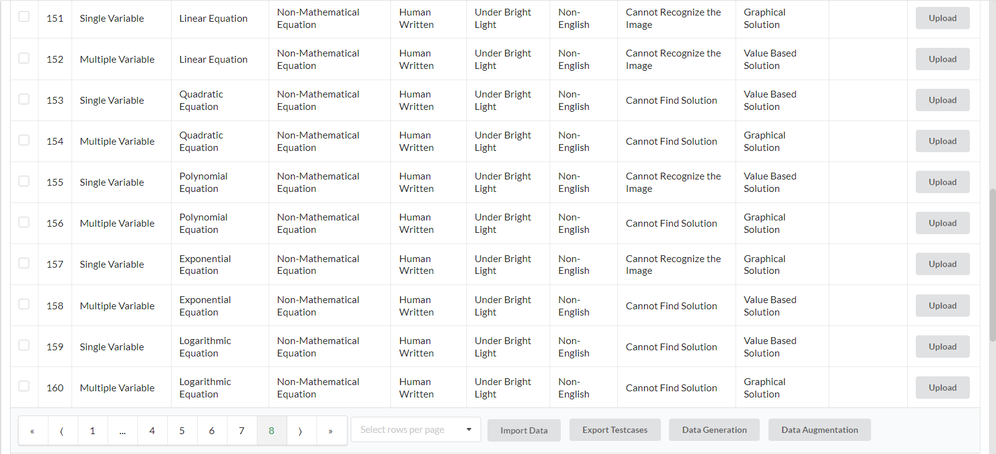

## 3.2 Test Case Reports

The following are some of the test case tables chosen from the AI test tool.

|  |  |
| --- | --- |
| **Test Case ID** | **1** |
| Test Topic | Algebra (Exponential Equations) |
| Test Description | Maths – Single Variable |
| AI Context Type | Maths |
| AI Input Type | Single variable |
| Test Case Input |  |
| Performed By | Saiteja Goruganthu |
| Execution Date | 16th November 2023 |
| AI Output Type | Value-based |
| Expected Result | x = 3 |
| Actual Result |  |
| Test Case Result | Pass |

|  |  |
| --- | --- |
| **Test Case ID** | **2** |
| Test Topic | Algebra (Exponential Equations) |
| Test Description | Maths – Multi Variable |
| AI Context Type | Maths |
| AI Input Type | Multiple variables |
| Test Case Input |  |
| Performed By | Saiteja Goruganthu |
| Execution Date | 16th November 2023 |
| AI Output Type | Graph based |
| Expected Result | A graph |
| Actual Result |  |
| Test Case Result | Pass |

|  |  |
| --- | --- |
| **Test Case ID** | **3** |
| Test Topic | Algebra (Exponential Equations) |
| Test Description | Non-Maths – Single Variable |
| AI Context Type | Non-Maths |
| AI Input Type | Single variable |
| Test Case Input |  |
| Performed By | Saiteja Goruganthu |
| Execution Date | 16th November 2023 |
| AI Output Type | Value-based |
| Expected Result | e-20 |
| Actual Result |  |
| Test Case Result | Fail |

|  |  |
| --- | --- |
| **Test Case ID** | **4** |
| Test Topic | Algebra (Exponential Equations) |
| Test Description | Non-Maths – Multi Variable |
| AI Context Type | Non-Maths |
| AI Input Type | Multiple variables |
| Test Case Input |  |
| Performed By | Saiteja Goruganthu |
| Execution Date | 16th November 2023 |
| AI Output Type | Value based |
| Expected Result | e-32 |
| Actual Result |  |
| Test Case Result | Fail |

|  |  |
| --- | --- |
| **Test Case ID** | **5** |
| Test Topic | Algebra (Exponential Equations) |
| Test Description | Computer Written – Single Variable |
| AI Context Type | Computer Written |
| AI Input Type | Single variable |
| Test Case Input |  |
| Performed By | Saiteja Goruganthu |
| Execution Date | 16th November 2023 |
| AI Output Type | Value-based |
| Expected Result | Solved equation |
| Actual Result |  |
| Test Case Result | Pass |

|  |  |
| --- | --- |
| **Test Case ID** | **6** |
| Test Topic | Algebra (Exponential Equations) |
| Test Description | Computer Written – Multi Variable |
| AI Context Type | Computer Written |
| AI Input Type | Multiple variables |
| Test Case Input |  |
| Performed By | Saiteja Goruganthu |
| Execution Date | 16th November 2023 |
| AI Output Type | Value-based |
| Expected Result | Solved equation |
| Actual Result |  |
| Test Case Result | Pass |

|  |  |
| --- | --- |
| **Test Case ID** | **7** |
| Test Topic | Algebra (Exponential Equations) |
| Test Description | Human Written – Single Variable |
| AI Context Type | Human Written |
| AI Input Type | Single variable |
| Test Case Input |  |
| Performed By | Saiteja Goruganthu |
| Execution Date | 16th November 2023 |
| AI Output Type | Value-based |
| Expected Result | Solved equation |
| Actual Result |  |
| Test Case Result | Pass |

|  |  |
| --- | --- |
| **Test Case ID** | **8** |
| Test Topic | Algebra (Exponential Equations) |
| Test Description | Human Written – Multi Variable |
| AI Context Type | Human Written |
| AI Input Type | Multiple variables |
| Test Case Input |  |
| Performed By | Saiteja Goruganthu |
| Execution Date | 16th November 2023 |
| AI Output Type | Value-based |
| Expected Result | Solved equation |
| Actual Result |  |
| Test Case Result | Pass |

|  |  |
| --- | --- |
| **Test Case ID** | **9** |
| Test Topic | Algebra (Exponential Equations) |
| Test Description | English – Single Variable |
| AI Context Type | English |
| AI Input Type | Single variable |
| Test Case Input |  |
| Performed By | Saiteja Goruganthu |
| Execution Date | 16th November 2023 |
| AI Output Type | Value-based |
| Expected Result | t = 6.93 |
| Actual Result |  |
| Test Case Result | Pass |

|  |  |
| --- | --- |
| **Test Case ID** | **10** |
| Test Topic | Algebra (Exponential Equations) |
| Test Description | English – Multi Variable |
| AI Context Type | English |
| AI Input Type | Multi variables |
| Test Case Input |  |
| Performed By | Saiteja Goruganthu |
| Execution Date | 16th November 2023 |
| AI Output Type | Value-based |
| Expected Result | Solved equation |
| Actual Result |  |
| Test Case Result | Pass |

|  |  |
| --- | --- |
| **Test Case ID** | **11** |
| Test Topic | Algebra (Exponential Equations) |
| Test Description | Non-English – Single Variable |
| AI Context Type | Non-English |
| AI Input Type | Single variable |
| Test Case Input |  |
| Performed By | Saiteja Goruganthu |
| Execution Date | 16th November 2023 |
| AI Output Type | Value-based |
| Expected Result | Error Message |
| Actual Result |  |
| Test Case Result | Pass |

|  |  |
| --- | --- |
| **Test Case ID** | **12** |
| Test Topic | Algebra (Exponential Equations) |
| Test Description | Non-English – Multi Variable |
| AI Context Type | Non-English |
| AI Input Type | Multiple variables |
| Test Case Input |  |
| Performed By | Saiteja Goruganthu |
| Execution Date | 16th November 2023 |
| AI Output Type | Value-based |
| Expected Result | Error Message |
| Actual Result |  |
| Test Case Result | Pass |

|  |  |
| --- | --- |
| **Test Case ID** | **13** |
| Test Topic | Algebra (Exponential Equations) |
| Test Description | Under Low Light – Single Variable |
| AI Context Type | Under Low Light |
| AI Input Type | Single Variable |
| Test Case Input |  |
| Performed By | Saiteja Goruganthu |
| Execution Date | 16th November 2023 |
| AI Output Type | Value-based |
| Expected Result | X = 4/15 |
| Actual Result |  |
| Test Case Result | Fail |

|  |  |
| --- | --- |
| **Test Case ID** | **14** |
| Test Topic | Algebra (Exponential Equations) |
| Test Description | Under Low Light – Multi Variable |
| AI Context Type | Under Low Light |
| AI Input Type | Multiple Variables |
| Test Case Input |  |
| Performed By | Saiteja Goruganthu |
| Execution Date | 16th November 2023 |
| AI Output Type | Value-based |
| Expected Result | Solved equation |
| Actual Result |  |
| Test Case Result | Pass |

|  |  |
| --- | --- |
| **Test Case ID** | **15** |
| Test Topic | Algebra (Exponential Equations) |
| Test Description | Under Bright Light – Single Variable |
| AI Context Type | Under Bright Light |
| AI Input Type | Single Variable |
| Test Case Input |  |
| Performed By | Saiteja Goruganthu |
| Execution Date | 16th November 2023 |
| AI Output Type | Value-based |
| Expected Result | X = 4/15 |
| Actual Result |  |
| Test Case Result | Pass |

|  |  |
| --- | --- |
| **Test Case ID** | **16** |
| Test Topic | Algebra (Exponential Equations) |
| Test Description | Under Bright Light – Multiple Variable |
| AI Context Type | Under Bright Light |
| AI Input Type | Multiple Variables |
| Test Case Input |  |
| Performed By | Saiteja Goruganthu |
| Execution Date | 16th November 2023 |
| AI Output Type | Graph-based |
| Expected Result | A graph |
| Actual Result |  |
| Test Case Result | Pass |

|  |  |
| --- | --- |
| **Test Case ID** | **17** |
| Test Topic | Algebra (Quadratic Equations) |
| Test Description | Basic Quadratic Equation |
| AI Context Type | Maths equation, Computer Written, English, bright light. |
| AI Input Type | Single variable |
| Test Case Input | X2 – 4 = 0 |
| Performed By | Sowjanya Bheemineni |
| Execution Date | 17th November 2023 |
| AI Output Type | Value-based |
| Expected Result | x = 2, x = -2 |
| Actual Result |  |
| Test Case Result | Pass |

|  |  |
| --- | --- |
| **Test Case ID** | **18** |
| Test Topic | Algebra (Quadratic Equations) |
| Test Description | Quadratic equation with non-integer coefficients |
| AI Context Type | Maths equation, Computer Written, English, bright light. |
| AI Input Type | Single variable |
| Test Case Input | 2x2 + 3x - 1 = 0 |
| Performed By | Sowjanya Bheemineni |
| Execution Date | 17th November 2023 |
| AI Output Type | Value-based |
| Expected Result | x = (-3+ $\sqrt{17)}/4$, x = (-3- $\sqrt{17)}/4$ |
| Actual Result |  |
| Test Case Result | Pass |

|  |  |
| --- | --- |
| **Test Case ID** | **19** |
| Test Topic | Algebra (Quadratic Equations) |
| Test Description | Quadratic equation with imaginary roots |
| AI Context Type | Maths equation, Computer Written, English, bright light. |
| AI Input Type | Single variable |
| Test Case Input | X2 + 4 = 0 |
| Performed By | Sowjanya Bheemineni |
| Execution Date | 17th November 2023 |
| AI Output Type | Value-based |
| Expected Result | x = 2i, x = -2i |
| Actual Result |  |
| Test Case Result | Pass |

|  |  |
| --- | --- |
| **Test Case ID** | **20** |
| Test Topic | Algebra (Quadratic Equations) |
| Test Description | Quadratic Equation with repeated real roots |
| AI Context Type | Maths equation, Computer Written, English, bright light. |
| AI Input Type | Single variable |
| Test Case Input | X2 – 6x + 9 = 0 |
| Performed By | Sowjanya Bheemineni |
| Execution Date | 17th November 2023 |
| AI Output Type | Value-based |
| Expected Result | X = 3 (double root) |
| Actual Result |  |
| Test Case Result | Pass |

|  |  |
| --- | --- |
| **Test Case ID** | **21** |
| Test Topic | Algebra (Quadratic Equations) |
| Test Description | Quadratic Equation with no real roots |
| AI Context Type | Maths equation, Human Written, English, bright light. |
| AI Input Type | Single variable |
| Test Case Input | x2 + 2 = 0 |
| Performed By | Sowjanya Bheemineni |
| Execution Date | 17th November 2023 |
| AI Output Type | Value-based |
| Expected Result | x = 2i, x = -2i |
| Actual Result |  |
| Test Case Result | Pass |

|  |  |
| --- | --- |
| **Test Case ID** | **22** |
| Test Topic | Algebra (Quadratic Equations) |
| Test Description | Quadratic Equation with zero constant term |
| AI Context Type | Maths equation, Human Written, English, bright light. |
| AI Input Type | Single variable |
| Test Case Input | 3x2 – 2x = 0 |
| Performed By | Sowjanya Bheemineni |
| Execution Date | 17th November 2023 |
| AI Output Type | Value-based |
| Expected Result | X = 0, x = 2/3 |
| Actual Result |  |
| Test Case Result | Pass |

|  |  |
| --- | --- |
| **Test Case ID** | **23** |
| Test Topic | Algebra (Quadratic Equations) |
| Test Description | Quadratic Equation with leading coefficient greater than 1 |
| AI Context Type | Maths equation, Computer Written, English, low light. |
| AI Input Type | Single variable |
| Test Case Input | 2x2 – 5x + 2 = 0 |
| Performed By | Sowjanya Bheemineni |
| Execution Date | 17th November 2023 |
| AI Output Type | Value-based |
| Expected Result | X = 2, x = 1/2 |
| Actual Result |  |
| Test Case Result | Pass |

|  |  |
| --- | --- |
| **Test Case ID** | **24** |
| Test Topic | Algebra (Quadratic Equations) |
| Test Description | Quadratic Equation in factored form |
| AI Context Type | Maths equation, Human Written, English, bright light. |
| AI Input Type | Single variable |
| Test Case Input | (x-3) (x+4) = 0 |
| Performed By | Sowjanya Bheemineni |
| Execution Date | 17th November 2023 |
| AI Output Type | Value-based |
| Expected Result | x = 3, x = -4 |
| Actual Result |  |
| Test Case Result | Pass |

|  |  |
| --- | --- |
| **Test Case ID** | **25** |
| Test Topic | Algebra (Quadratic Equations) |
| Test Description | Quadratic Equation with coefficients as decimals |
| AI Context Type | Maths equation, Computer Written, English, bright light. |
| AI Input Type | Single variable |
| Test Case Input | 0.5 x2 + 1.5x - 1 = 0 |
| Performed By | Sowjanya Bheemineni |
| Execution Date | 17th November 2023 |
| AI Output Type | Value-based |
| Expected Result | x = 0.56, x = -3.56 |
| Actual Result |  |
| Test Case Result | Pass |

|  |  |
| --- | --- |
| **Test Case ID** | **26** |
| Test Topic | Algebra (Quadratic Equations) |
| Test Description | Quadratic Equation with two distinct real roots |
| AI Context Type | Maths equation, Computer Written, English, bright light. |
| AI Input Type | Single variable |
| Test Case Input | x2 – 5x + 6 = 0 |
| Performed By | Sowjanya Bheemineni |
| Execution Date | 17th November 2023 |
| AI Output Type | Value-based |
| Expected Result | x = 2, x = 3 |
| Actual Result |  |
| Test Case Result | Pass |

|  |  |
| --- | --- |
| **Test Case ID** | **27** |
| Test Topic | Algebra (Quadratic Equations) |
| Test Description | Quadratic Equation with positive coefficients |
| AI Context Type | Maths equation, Computer Written, English, bright light. |
| AI Input Type | Single variable |
| Test Case Input | 2x2 +7x + 3 = 0 |
| Performed By | Sowjanya Bheemineni |
| Execution Date | 17th November 2023 |
| AI Output Type | Value-based |
| Expected Result | x = -1/2, x = -3 |
| Actual Result |  |
| Test Case Result | Pass |

|  |  |
| --- | --- |
| **Test Case ID** | **28** |
| Test Topic | Algebra (Quadratic Equations) |
| Test Description | Quadratic Equation with large coefficients |
| AI Context Type | Maths equation, Computer Written, English, bright light. |
| AI Input Type | Single variable |
| Test Case Input | 5x2 –12x + 8 = 0 |
| Performed By | Sowjanya Bheemineni |
| Execution Date | 17th November 2023 |
| AI Output Type | Value-based |
| Expected Result | X = (6/5) + (2/5) i, x = (6/5) - (2/5)i |
| Actual Result |  |
| Test Case Result | Pass |

|  |  |
| --- | --- |
| **Test Case ID** | **29** |
| Test Topic | Algebra (Quadratic Equations) |
| Test Description | Quadratic Equation with negative discriminant |
| AI Context Type | Maths equation, Computer Written, English, bright light. |
| AI Input Type | Single variable |
| Test Case Input | 3x2 – 4x + 5 = 0 |
| Performed By | Sowjanya Bheemineni |
| Execution Date | 17th November 2023 |
| AI Output Type | Value-based |
| Expected Result | x= (2/3) +($\frac{\sqrt{11}}{3}i$), x = (2/3) - ($\frac{\sqrt{11}}{3}i$) |
| Actual Result |  |
| Test Case Result | Pass |

|  |  |
| --- | --- |
| **Test Case ID** | **30** |
| Test Topic | Algebra (Quadratic Equations) |
| Test Description | Quadratic Equation with zero coefficient for x term |
| AI Context Type | Maths equation, Human Written, English, low light. |
| AI Input Type | Single variable |
| Test Case Input | 4x2 – 9 = 0 |
| Performed By | Sowjanya Bheemineni |
| Execution Date | 17th November 2023 |
| AI Output Type | Value-based |
| Expected Result | X = 3/2, x = -3/2 |
| Actual Result |  |
| Test Case Result | Pass |

|  |  |
| --- | --- |
| **Test Case ID** | **31** |
| Test Topic | Algebra (Quadratic Equations) |
| Test Description | Quadratic Equation with a coefficient of 1 for x2 |
| AI Context Type | Maths equation, Computer Written, English, bright light. |
| AI Input Type | Single variable |
| Test Case Input | x2 + 8x + 16 = 0 |
| Performed By | Sowjanya Bheemineni |
| Execution Date | 17th November 2023 |
| AI Output Type | Value-based |
| Expected Result | X = -4 (double root) |
| Actual Result |  |
| Test Case Result | Pass |

|  |  |
| --- | --- |
| **Test Case ID** | **32** |
| Test Topic | Algebra (Quadratic Equations) |
| Test Description | Quadratic Equation with coefficient of 0 for x term |
| AI Context Type | Maths equation, Human Written, English, low light. |
| AI Input Type | Single variable |
| Test Case Input | 2x2 + 5 = 0 |
| Performed By | Sowjanya Bheemineni |
| Execution Date | 17th November 2023 |
| AI Output Type | Value-based |
| Expected Result | x = , x = - |
| Actual Result |  |
| Test Case Result | Pass |

|  |  |
| --- | --- |
| **Test Case ID** | **33** |
| Test Topic | Algebra (Quadratic Equations) |
| Test Description | Quadratic Equation with a negative constant term |
| AI Context Type | Maths equation, Computer Written, English, bright light. |
| AI Input Type | Single variable |
| Test Case Input | x2 – 3x - 6 = 0 |
| Performed By | Sowjanya Bheemineni |
| Execution Date | 17th November 2023 |
| AI Output Type | Value-based |
| Expected Result | x = ( , x = |
| Actual Result |  |
| Test Case Result | Pass |

|  |  |
| --- | --- |
| **Test Case ID** | **34** |
| Test Topic | Algebra (Quadratic Equations) |
| Test Description | Quadratic Equation with large coefficients |
| AI Context Type | Maths equation, Computer Written, English, bright light. |
| AI Input Type | Single variable |
| Test Case Input | 1000x2 - 2000x + 1000 = 0 |
| Performed By | Sowjanya Bheemineni |
| Execution Date | 17th November 2023 |
| AI Output Type | Value-based |
| Expected Result | x = 1 |
| Actual Result |  |
| Test Case Result | Pass |

|  |  |
| --- | --- |
| **Test Case ID** | **35** |
| Test Topic | Algebra (Quadratic Equations) |
| Test Description | Quadratic Equation with a mix of positive and negative coefficients |
| AI Context Type | Maths equation, Computer Written, Non-English, bright light. |
| AI Input Type | Single variable |
| Test Case Input | -2x2 + 4x -1 = 0 |
| Performed By | Sowjanya Bheemineni |
| Execution Date | 17th November 2023 |
| AI Output Type | Value-based |
| Expected Result | x = $(√2$ + 2)/2, x = $(-√2$ + 2)/2 |
| Actual Result |  |
| Test Case Result | Pass |

|  |  |
| --- | --- |
| **Test Case ID** | **36** |
| Test Topic | Algebra (Quadratic Equations) |
| Test Description | Quadratic Equation with fractional coefficients |
| AI Context Type | Maths equation, Computer Written, Non-English, bright light. |
| AI Input Type | Single variable |
| Test Case Input | (1/2) x2 + (3/4)x - (5/2) = 0 |
| Performed By | Sowjanya Bheemineni |
| Execution Date | 17th November 2023 |
| AI Output Type | Value-based |
| Expected Result | x = $(√89$- 3)/4, x = $(-√89$- 3)/4 |
| Actual Result |  |
| Test Case Result | Pass |

|  |  |
| --- | --- |
| **Test Case ID** | **37** |
| Test Topic | Algebra (Linear equations) |
| Test Description | Single variable equation |
| AI Context Type | Maths Equation, Computer written, Under bright light. |
| AI Input Type | Single variable |
| Test Case Input | 2x + 3 = 11 |
| Performed By | Sohan Leburu |
| Execution Date | 18th November 2023 |
| AI Output Type | Non-graphical |
| Expected Result | X = 4 |
| Actual Result |  |
| Test Case Result | Pass |

|  |  |
| --- | --- |
| **Test Case ID** | **38** |
| Test Topic | Algebra (Linear equations) |
| Test Description | Single variable equation |
| AI Context Type | Maths Equation, Human Written, English, Under bright light. |
| AI Input Type | Single variable |
| Test Case Input | 5x – 7 = 18 |
| Performed By | Sohan Leburu |
| Execution Date | 18th November 2023 |
| AI Output Type | Non-graphical |
| Expected Result | X = 5 |
| Actual Result |  |
| Test Case Result | Pass |

|  |  |
| --- | --- |
| **Test Case ID** | **39** |
| Test Topic | Algebra (Linear equations) |
| Test Description | Single variable equation |
| AI Context Type | Maths equation, Computer written, English, Under low light. |
| AI Input Type | Single variable |
| Test Case Input | 3x + 4 = -2 |
| Performed By | Sohan Leburu |
| Execution Date | 18th November 2023 |
| AI Output Type | Non- graphical |
| Expected Result | X = -2 |
| Actual Result |  |
| Test Case Result | Pass |

|  |  |
| --- | --- |
| **Test Case ID** | **40** |
| Test Topic | Algebra (Linear equations) |
| Test Description | Single variable equation |
| AI Context Type | Non-Maths Equation, Computer Written, English, Under bright light. |
| AI Input Type | Single variable |
| Test Case Input | Imagine you are a detective trying to solve a mystery. You know that exactly 3 clues lead to the location of a hidden treasure. You already have 4 clues in your possession. To find the treasure, you need to figure out which one of your clues is a red herring and doesn't lead to the treasure. |
| Performed By | Sohan Leburu |
| Execution Date | 18th November 2023 |
| AI Output Type | Non- graphical |
| Expected Result | X = -2 |
| Actual Result |  |
| Test Case Result | Pass |

|  |  |
| --- | --- |
| **Test Case ID** | **41** |
| Test Topic | Algebra (Linear equations) |
| Test Description | Single variable equation |
| AI Context Type | Non-Maths Equation, Human Written, English, Under bright light. |
| AI Input Type | Single variable |
| Test Case Input | Imagine you're organizing a book club and you need to choose exactly 5 books for the upcoming month. You currently have a selection of 7 books to choose from. However, you discover that to meet the club's theme, you need to exclude 2 books that don't fit the criteria. |
| Performed By | Sohan Leburu |
| Execution Date | 18th November 2023 |
| AI Output Type | Non-graphical |
| Expected Result | X = 5 |
| Actual Result |  |
| Test Case Result | Pass |

|  |  |
| --- | --- |
| **Test Case ID** | **42** |
| Test Topic | Algebra (Linear equations) |
| Test Description | Single variable equation |
| AI Context Type | Maths, Computer written, English, Under Lowlight. |
| AI Input Type | Single variable |
| Test Case Input | 4x – 5 =11 |
| Performed By | Sohan Leburu |
| Execution Date | 18th November 2023 |
| AI Output Type | Non-graphical |
| Expected Result | X = 4 |
| Actual Result |  |
| Test Case Result | Pass |

|  |  |
| --- | --- |
| **Test Case ID** | **43** |
| Test Topic | Algebra (Linear equations) |
| Test Description | Multiple variable |
| AI Context Type | Maths equation, Computer Written, English, Under bright light. |
| AI Input Type | Multi variable |
| Test Case Input | Y = 2x + 3 |
| Performed By | Sohan Leburu |
| Execution Date | 18th November 2023 |
| AI Output Type | Graphical |
| Expected Result | X = 0, x= 2 |
| Actual Result |  |
| Test Case Result | Fail |

|  |  |
| --- | --- |
| **Test Case ID** | **44** |
| Test Topic | Algebra (Linear equations) |
| Test Description | Multiple variable |
| AI Context Type | Maths, Human Written, English, Under bright light. |
| AI Input Type | Multi variable |
| Test Case Input | Y = -3x + 6 |
| Performed By | Sohan Leburu |
| Execution Date | 18th November 2023 |
| AI Output Type | graphical |
| Expected Result | X=2 |
| Actual Result |  |
| Test Case Result | Pass |

|  |  |
| --- | --- |
| **Test Case ID** | **45** |
| Test Topic | Algebra (Linear equations) |
| Test Description | Multi-variable maths equation |
| AI Context Type | Maths Equation, Human Written, English, Under Lowlight. |
| AI Input Type | Multi variable |
| Test Case Input | Y = x-4 |
| Performed By | Sohan Leburu |
| Execution Date | 18th November 2023 |
| AI Output Type | graphical |
| Expected Result | X = 4 |
| Actual Result |  |
| Test Case Result | Pass |

|  |  |
| --- | --- |
| **Test Case ID** | **46** |
| Test Topic | Algebra (Linear equations) |
| Test Description | Multi-variable maths equation |
| AI Context Type | Maths equation, Computer Written, English, Under Lowlight. |
| AI Input Type | multi variable |
| Test Case Input | Y = 3x + 2 |
| Performed By | Sohan Leburu |
| Execution Date | 18th November 2023 |
| AI Output Type | graphical |
| Expected Result | X = -2/3 |
| Actual Result |  |
| Test Case Result | Pass |

|  |  |
| --- | --- |
| **Test Case ID** | **47** |
| Test Topic | Algebra (Linear equations) |
| Test Description | Multi-variable maths equation |
| AI Context Type | Maths Equation, Computer Written, English, Under Lowlight. |
| AI Input Type | multi variable |
| Test Case Input | 2x + 3y = 8  X – y = 1 |
| Performed By | Sohan Leburu |
| Execution Date | 18th November 2023 |
| AI Output Type | Non-graphical |
| Expected Result | X = 11/5, y = 6/5 |
| Actual Result |  |
| Test Case Result | Pass |

|  |  |
| --- | --- |
| **Test Case ID** | **48** |
| Test Topic | Algebra (Linear equations) |
| Test Description | Multi-variable maths equation |
| AI Context Type | Maths equation, Human Written, English, Under Lowlight. |
| AI Input Type | multi variable |
| Test Case Input |  |
| Performed By | Sohan Leburu |
| Execution Date | 18th November 2023 |
| AI Output Type | Non-graphical |
| Expected Result | X = 2, y =2 |
| Actual Result |  |
| Test Case Result | Pass |

|  |  |
| --- | --- |
| **Test Case ID** | **49** |
| Test Topic | Algebra (Linear equations) |
| Test Description | Multi-variable maths equation |
| AI Context Type | Maths Equation, Computer Written, English, Under bright light. |
| AI Input Type | multi variable |
| Test Case Input |  |
| Performed By | Sohan Leburu |
| Execution Date | 18th November 2023 |
| AI Output Type | Non-graphical |
| Expected Result | X = 18/7, y = 15/7 |
| Actual Result |  |
| Test Case Result | Pass |

|  |  |
| --- | --- |
| **Test Case ID** | **50** |
| Test Topic | Algebra (Linear equations) |
| Test Description | Non-mathematical expression |
| AI Context Type | Non-Maths Equation, Computer Written, English, bright light. |
| AI Input Type | Single variable |
| Test Case Input | Three(x) + Two(x) = Nine |
| Performed By | Sohan Leburu |
| Execution Date | 18th November 2023 |
| AI Output Type | - |
| Expected Result | Error |
| Actual Result |  |
| Test Case Result | Pass |

|  |  |
| --- | --- |
| **Test Case ID** | **51** |
| Test Topic | Algebra (Linear equations) |
| Test Description | Non-mathematical expression |
| AI Context Type | Non-Maths Equation, Computer Written, English, Under Lowlight. |
| AI Input Type | Single variable or multi variable |
| Test Case Input | Three(x) + Two(x) = Nine |
| Performed By | Sohan Leburu |
| Execution Date | 18th November 2023 |
| AI Output Type | - |
| Expected Result | Error |
| Actual Result |  |
| Test Case Result | Pass |

|  |  |
| --- | --- |
| **Test Case ID** | **52** |
| Test Topic | Algebra (Linear equations) |
| Test Description | Blank |
| AI Context Type | Maths/Non-Maths Equation, Computer or Human Written, English or Non-English, Under Lowlight or bright light. |
| AI Input Type | Single variable or multi variable |
| Test Case Input |  |
| Performed By | Sohan Leburu |
| Execution Date | 18th November 2023 |
| AI Output Type | Error |
| Expected Result | Cannot recognize the image |
| Actual Result |  |
| Test Case Result | Pass |

|  |  |
| --- | --- |
| **Test Case ID** | **53** |
| Test Topic | Algebra (Linear equations) |
| Test Description | Non-mathematical English |
| AI Context Type | Non-Maths Equation, Computer written, English, Under Lowlight or bright light. |
| AI Input Type | Multi variable |
| Test Case Input | Imagine you're trying to balance a scale. On one side, you have a bag that's labeled "2x - 5", but there's a special rule: if the bag's contents are negative, you have to reverse them to make them positive. On the other side, you have a bag labeled "3x + 1".  Your goal is to make sure both sides of the scale have the same weight. This is tricky because the "2x - 5" bag can change depending on what "x" is |
| Performed By | Sohan Leburu |
| Execution Date | 18th November 2023 |
| AI Output Type | Error |
| Expected Result | Cannot recognize the problem |
| Actual Result |  |
| Test Case Result | Pass |

|  |  |
| --- | --- |
| **Test Case ID** | **54** |
| Test Topic | Algebra (Linear equations) |
| Test Description | Single variable equation |
| AI Context Type | Maths Equation, Computer written, English, Under bright light. |
| AI Input Type | Single variable |
| Test Case Input | 5x + 3 = 5x - 2 |
| Performed By | Sohan Leburu |
| Execution Date | 18th November 2023 |
| AI Output Type | No solution |
| Expected Result | No solution |
| Actual Result |  |
| Test Case Result | Pass |

|  |  |
| --- | --- |
| **Test Case ID** | **55** |
| Test Topic | Algebra (Linear equations) |
| Test Description | Single variable equat |
| AI Context Type | Maths Equation, Computer written, English, Under low light. |
| AI Input Type | Single variable |
| Test Case Input | 4(x – 2) = 4x + 8 |
| Performed By | Sohan Leburu |
| Execution Date | 18th November 2023 |
| AI Output Type | No solution |
| Expected Result | No solution |
| Actual Result |  |
| Test Case Result | Pass |

|  |  |
| --- | --- |
| **Test Case ID** | **56** |
| Test Topic | Algebra (Linear equations) |
| Test Description | Multiple variable |
| AI Context Type | Maths Equation, Computer Written, English, Under bright light. |
| AI Input Type | multi variable |
| Test Case Input | 2x + 3y = 4  4x + 6y = 12 |
| Performed By | Sohan Leburu |
| Execution Date | 18th November 2023 |
| AI Output Type | No solution |
| Expected Result | No solution |
| Actual Result |  |
| Test Case Result | Pass |

|  |  |
| --- | --- |
| **Test Case ID** | **57** |
| Test Topic | Algebra (Polynomial Equations) |
| Test Description | 4th power Equation |
| AI Context Type | Maths Equation |
| AI Input Type | Single variable |
| Test Case Input | 2x4 – 2x3 – 14x2 + 2x + 12 = 0 |
| Performed By | Harish Marepalli |
| Execution Date | 20th November 2023 |
| AI Output Type | Value-based |
| Expected Result | x = -2, x = -1, x = 1, x = 3 |
| Actual Result |  |
| Test Case Result | Pass |
| **Test Case ID** | **58** |
| Test Topic | Algebra (Polynomial Equations) |
| Test Description | Word Problem |
| AI Context Type | Non-Maths Equation |
| AI Input Type | Single variable |
| Test Case Input | If John has 25 cars, then what will be the new total number of cars if he sells out one from it? |
| Performed By | Harish Marepalli |
| Execution Date | 20th November 2023 |
| AI Output Type | Value-based |
| Expected Result | 24 |
| Actual Result | Error (Unable to read the word problem) |
| Test Case Result | Fail |

|  |  |
| --- | --- |
| **Test Case ID** | **59** |
| Test Topic | Algebra (Polynomial Equations) |
| Test Description | Cubic Equation |
| AI Context Type | Computer Written |
| AI Input Type | Single variable |
| Test Case Input | x3 – 1 = 0 |
| Performed By | Harish Marepalli |
| Execution Date | 20th November 2023 |
| AI Output Type | Value-based |
| Expected Result | x = 1, x = −1/2 + (sqrt (3)/2)i, x = −1/2 - (sqrt (3)/2)i |
| Actual Result |  |
| Test Case Result | Pass |

|  |  |
| --- | --- |
| **Test Case ID** | **60** |
| Test Topic | Algebra (Polynomial Equations) |
| Test Description | Quadratic Equation |
| AI Context Type | Human Written |
| AI Input Type | Single variable |
| Test Case Input |  |
| Performed By | Harish Marepalli |
| Execution Date | 20th November 2023 |
| AI Output Type | Value-based |
| Expected Result | x = -5/2, x = -1 |
| Actual Result |  |
| Test Case Result | Pass |

|  |  |
| --- | --- |
| **Test Case ID** | **61** |
| Test Topic | Algebra (Polynomial Equations) |
| Test Description | Word Problem |
| AI Context Type | English |
| AI Input Type | Single variable |
| Test Case Input | If the value of x2 is 25, what is the value of x2 - 1? |
| Performed By | Harish Marepalli |
| Execution Date | 20th November 2023 |
| AI Output Type | Value-based |
| Expected Result | x = 24 |
| Actual Result | Error (Unable to read the word problem) |
| Test Case Result | Fail |

|  |  |
| --- | --- |
| **Test Case ID** | **62** |
| Test Topic | Algebra (Polynomial Equations) |
| Test Description | Word Problem |
| AI Context Type | Non-English |
| AI Input Type | Single variable |
| Test Case Input | x3 విలువ 25 అయితే, x3 మైనస్ 1 విలువ ఎంత? |
| Performed By | Harish Marepalli |
| Execution Date | 20th November 2023 |
| AI Output Type | Value-based |
| Expected Result | Cannot recognize the problem |
| Actual Result | Error (Unable to read the word problem) |
| Test Case Result | Pass |

|  |  |
| --- | --- |
| **Test Case ID** | **63** |
| Test Topic | Algebra (Polynomial Equations) |
| Test Description | 4th power equation |
| AI Context Type | Under Lowlight |
| AI Input Type | Single variable |
| Test Case Input |  |
| Performed By | Harish Marepalli |
| Execution Date | 20th November 2023 |
| AI Output Type | Value-based |
| Expected Result | x = -2, x = -1, x = 1, x = 3 |
| Actual Result |  |
| Test Case Result | Pass |

|  |  |
| --- | --- |
| **Test Case ID** | **64** |
| Test Topic | Algebra (Polynomial Equations) |
| Test Description | 4th power equation |
| AI Context Type | Under Bright light |
| AI Input Type | Single variable |
| Test Case Input |  |
| Performed By | Harish Marepalli |
| Execution Date | 20th November 2023 |
| AI Output Type | Value-based |
| Expected Result | x = -3, x = 2 |
| Actual Result |  |
| Test Case Result | Pass |

|  |  |
| --- | --- |
| **Test Case ID** | **65** |
| Test Topic | Algebra (Polynomial Equations) |
| Test Description | Quadratic equation |
| AI Context Type | Maths Equation |
| AI Input Type | Multi variable |
| Test Case Input | 3x2y + 2xy2 − 5x + 7y − 9=0 |
| Performed By | Harish Marepalli |
| Execution Date | 20th November 2023 |
| AI Output Type | Value-based |
| Expected Result | dy/dx = -(6xy+2y2 -5)/(3x2 +4xy+7) |
| Actual Result |  |
| Test Case Result | Pass |

|  |  |
| --- | --- |
| **Test Case ID** | **66** |
| Test Topic | Algebra (Polynomial Equations) |
| Test Description | Word problem |
| AI Context Type | Non-Maths Equation |
| AI Input Type | Multi variable |
| Test Case Input | If Steven has 9 pens and 10 pencils, then what will be the new total number of pens and pencils if he sells out one of each? |
| Performed By | Harish Marepalli |
| Execution Date | 20th November 2023 |
| AI Output Type | Value-based |
| Expected Result | 8, 9 |
| Actual Result | Error (Unable to read the word problem) |
| Test Case Result | Fail |

|  |  |
| --- | --- |
| **Test Case ID** | **67** |
| Test Topic | Algebra (Polynomial Equations) |
| Test Description | Word problem |
| AI Context Type | Computer written |
| AI Input Type | Multi variable |
| Test Case Input | 4x2 - 3xy - 2y2 + x – y + 6 = 0 |
| Performed By | Harish Marepalli |
| Execution Date | 20th November 2023 |
| AI Output Type | Value-based |
| Expected Result | dy/dx = (8x-3y+1)/(3x+4y+1) |
| Actual Result |  |
| Test Case Result | Pass |

|  |  |
| --- | --- |
| **Test Case ID** | **68** |
| Test Topic | Algebra (Polynomial Equations) |
| Test Description | Word problem |
| AI Context Type | Human written |
| AI Input Type | Multi variable |
| Test Case Input | x2 - 4xy + 3y2 = 0 |
| Performed By | Harish Marepalli |
| Execution Date | 20th November 2023 |
| AI Output Type | Value-based |
| Expected Result | dy/dx = (2y - x)/(-2x + 3y) |
| Actual Result |  |
| Test Case Result | Pass |

|  |  |
| --- | --- |
| **Test Case ID** | **69** |
| Test Topic | Algebra (Polynomial Equations) |
| Test Description | Word problem |
| AI Context Type | English |
| AI Input Type | Multi variable |
| Test Case Input | If the value of x is 25 and y is 10, what is the value of xy? |
| Performed By | Harish Marepalli |
| Execution Date | 20th November 2023 |
| AI Output Type | Value-based |
| Expected Result | 250 |
| Actual Result |  |
| Test Case Result | Pass |

|  |  |
| --- | --- |
| **Test Case ID** | **70** |
| Test Topic | Algebra (Polynomial Equations) |
| Test Description | Word problem |
| AI Context Type | Non-English |
| AI Input Type | Multi variable |
| Test Case Input | x విలువ 25 మరియు y 10 అయితే, xy విలువ ఎంత? |
| Performed By | Harish Marepalli |
| Execution Date | 20th November 2023 |
| AI Output Type | Value-based |
| Expected Result | Cannot recognize the problem |
| Actual Result |  |
| Test Case Result | Fail |

|  |  |
| --- | --- |
| **Test Case ID** | **71** |
| Test Topic | Algebra (Polynomial Equations) |
| Test Description | Quadratic Equation |
| AI Context Type | Under Lowlight |
| AI Input Type | Multi variable |
| Test Case Input |  |
| Performed By | Harish Marepalli |
| Execution Date | 20th November 2023 |
| AI Output Type | Value-based |
| Expected Result | dy/dx = -(2x + 3y)/(3(x + y)) |
| Actual Result |  |
| Test Case Result | Pass |

|  |  |
| --- | --- |
| **Test Case ID** | **72** |
| Test Topic | Algebra (Polynomial Equations) |
| Test Description | Quadratic Equation |
| AI Context Type | Under Bright light |
| AI Input Type | Multi variable |
| Test Case Input |  |
| Performed By | Harish Marepalli |
| Execution Date | 20th November 2023 |
| AI Output Type | Value-based |
| Expected Result | dy/dx = -(19y + 8x)/(19x + 4y) |
| Actual Result |  |
| Test Case Result | Pass |

## 3.3 Test Case Analysis (Statistics)

### 3.3.1 Overall Test Case Results

|  |  |
| --- | --- |
|  | **PhotoMath** |
| Pass Rate | 64/72 |
| Pass Percentage | 88.88 |

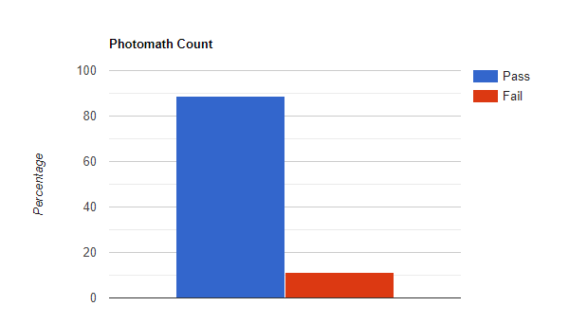

### 3.3.2 Context Test Case Results

|  |  |
| --- | --- |
|  | **PhotoMath** |
| Maths Equation | 37/38 = 97.36% |
| Non-Maths Equation | 5/9 = 55.55% |
| Computer Written | 32/33 = 96.96% |
| Human Written | 14/14 = 100% |
| English | 38/40 = 95% |
| Non-English | 5/6 = 83.33% |
| Under Low Light | 14/15 = 93.33% |
| Under Bright Light | 30/31 = 96.77% |

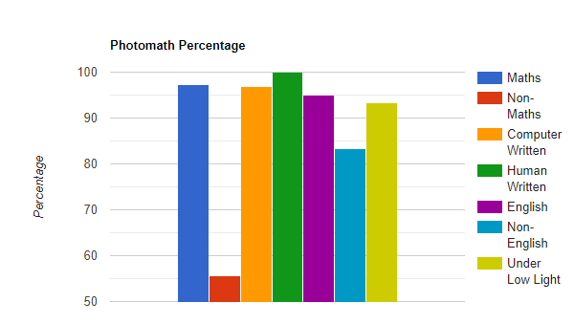

### 3.3.3 Input Test Case Results

|  |  |
| --- | --- |
|  | **PhotoMath** |
| Exponential | 13/16 = 81.25% |
| Linear | 20/20 = 100% |
| Quadratic | 19/20 = 95% |
| Polynomial | 12/16 = 75% |

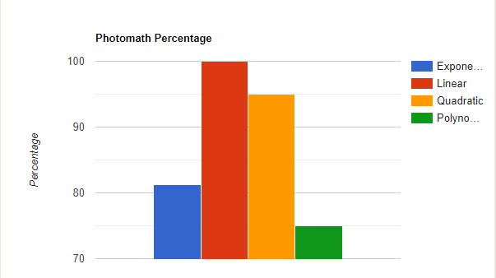

### 3.3.4 Context and Input Test Case Results

|  |  |
| --- | --- |
|  | **PhotoMath** |
| Context Pass Percentage | 175/186 = 94.08 |
| Input Pass Percentage | 64/72 = 88.88 |

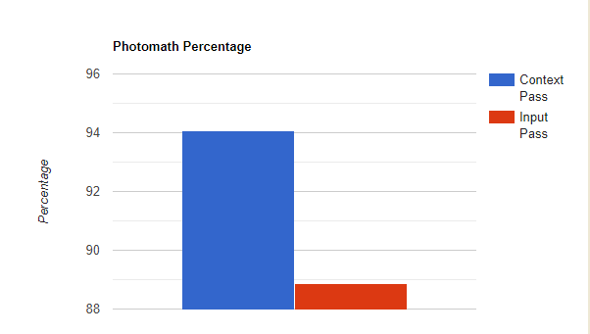

### 3.3.5 Test Report

* We used Photomath application to test and solve few math problems. We took several context features into consideration such as clarity, language, and various types of content.
* We believe accuracy as an important parameter when solving mathematical equations irrespective of the application used.
* While testing based on context test cases, the application fails to detect the problem when input is given in any language other than English.
* While testing the application with input having word-based problem, Photomath application failed to detect the equations.
* After looking at the results of the testing, Photomath needs a lot of work in solving word-based equations under different context conditions.

# AI Function Test Results and Test Criteria

## 4.1 AI Model Based Test Complexity

We used black box testing techniques like Boundary value testing, category based

testing, scenario-based testing, and equivalence partitioning testing for conventional

testing. In regard of AI testing, we used an AI tool for generating various test cases

based on various context features.

|  |  |
| --- | --- |
| **Test Method** | **Photo math** |
| Boundary Value Testing | 100% |
| Category Partition Testing | 78.62% |
| Scenario Testing | 100% |

## AI Function Bug Analysis

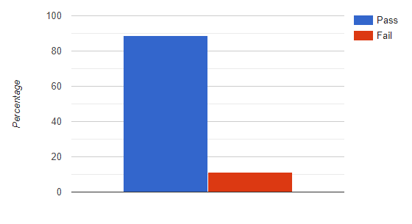

With the AI tool generated test cases, we can see above that the pass percentage is good but needs a little improvement.

## 4.3 AI Function Test Quality Assessment

The testing method we used here is category partition testing. After the test cases were

separated based on the various input and context criteria. We selected at least one input

from each category.

4.3.1 Test Criteria

● At Least one test case from each input and context criteria are tested and

solutions are displayed for problems which can be solved and error message for

problems which can’t be solved.

4.3.2 Test Coverage

● All input, context and output classifications were covered by testing at least one

test case from each domain.